

**QGIS Lab Series**

**Lab 2: Spatial Data Models**

**Objective – Explore and Understand Spatial Data Models**

**Document Version:** **2014-06-02 (Final)**

**Author:**

Kurt Menke, GISP



**Contents**

1 Introduction 2

2 Objective: Explore and Understand Geospatial Data Models 2

3 How Best to Use Video Walk Through with this Lab 3

Task 1 Learn to work with QGIS Browser 3

Task 2 Become familiar with geospatial data models 5

Task 3 Viewing geospatial data in QGIS Desktop 9

5 Conclusion 18

6 Discussion Questions 18

1. Introduction

In this lab, students will explore and manage geospatial data using two modules of the FOSS4G software QGIS: QGIS Browser and QGIS Desktop. QGIS Browser is an application designed to preview and manage geospatial data. It is analogous to Windows Explorer, but works specifically with geospatial datasets. QGIS Desktop is the companion application used to perform spatial analyses and make maps.

This lab will also introduce students to the QGIS interface, which is used throughout the course. It is important to learn the concepts in this lab as future labs will require the skills covered in this lab.

This lab includes the following tasks:

* Task 1 – Learn to work with QGIS Browser.
* Task 2 – Become familiar with geospatial data models.
* Task 3 – Viewing geospatial data in QGIS Desktop.

1. Objective: Explore and Understand Geospatial Data Models

Geographic Information Systems model the real world with representations of objects such as lakes, roads and towns. Geospatial data models are the means used to represent these features. They are composed to two parts: spatial features and attributes that when combined create a model of reality.

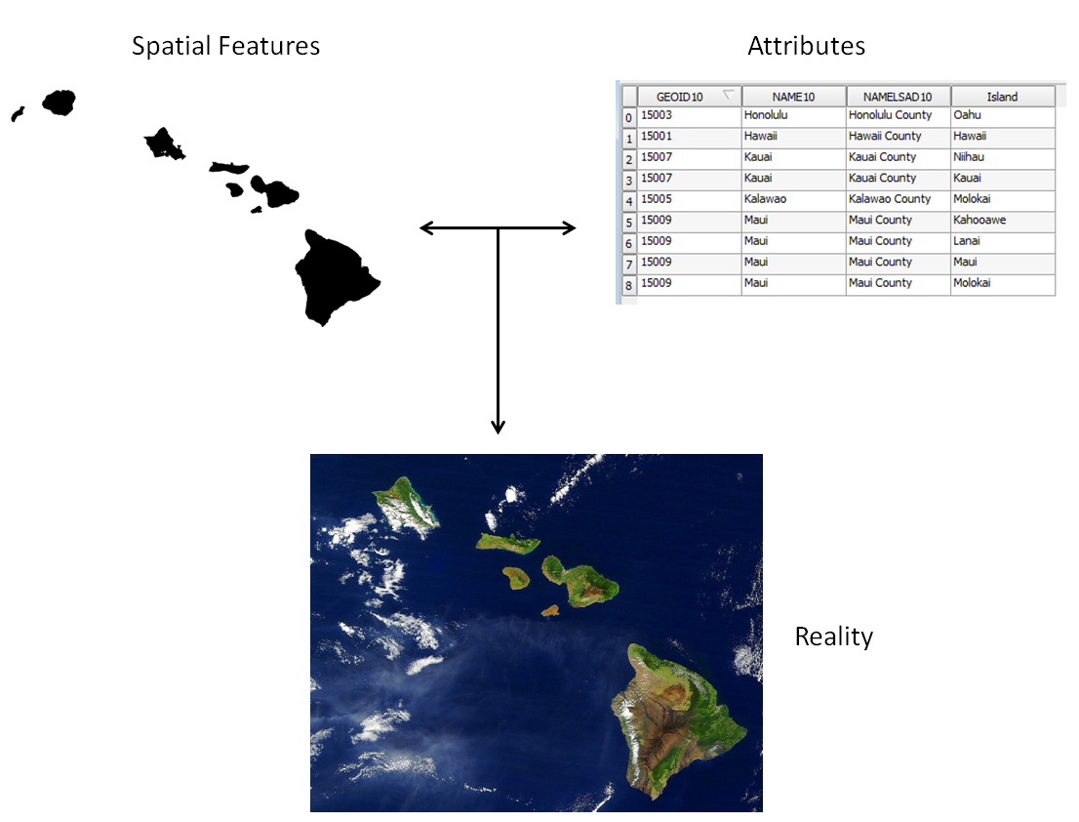

**Figure 1: Two parts of the geospatial data model**

There are two main geospatial data models: vector and raster.

**Vector Data Model** – best for modeling discrete objects. Vector data comes in three forms: point, line and polygon.

**Raster Data Model** – this model is best for modeling continuous objects. A raster is composed of a matrix of contiguous cells, with each cell (pixel) holding a single numeric value.

1. How Best to Use Video Walk Through with this Lab

To aid in your completion of this lab, each lab task has an associated video that demonstrates how to complete the task. The intent of these videos is to help you move forward if you become stuck on a step in a task, or if you wish to see every step required to complete the tasks.

We recommend that you do not watch the videos before you attempt the tasks. The reasoning for this is that while you are learning the software and searching for buttons, menus, and other features…, you will better remember where these items are and, perhaps, discover other features along the way if you discover them on your own. With that being said, please use the videos in the way that will best facilitate your learning and successful completion of this lab.

1. Learn to work with QGIS Browser

In this task, you will become familiar with QGIS Browser. The first step in working on a project with geospatial datasets is to organize your workspace. It is important that we organize datasets logically on the computer and make them easy to find. In this task, you will obtain a copy of the lab data and explore how the data is organized using QGIS Browser.

1. The data for this lab is located at C:\GIS101\Lab 2 on the lab machine. You may copy the entire GST 101 folder to a new working directory of your choosing.
2. To do this use Windows Explorer. **Click Start 🡪 All Programs 🡪 Accessories 🡪 Window Explorer**.
3. **Click** on the **Local Disk (C:)** drive on the left hand file tree. NOTE: You may have to expand the Computer by clicking the arrow to the left.
4. Locate the GST 101 Folder. **Right click** on the **GST101** folder and choose **Copy** from the context menu.
5. Choose your working directory.
6. **Right click** on your new working directory and choose **Paste** from the context menu.

Now open QGIS Browser

1. **Click Start 🡪 All Programs 🡪 OSGeo4W 🡪 QGIS Browser.**

The interface to QGIS Browser is simple and clean (**Figure 2**). The **File Tree** is displayed on the left. (NOTE: your machine may have a different set and number of drives listed here. This is fine.) Below the drives are **Database Connections**. There are no connections to any databases at this point. The **Display Window** takes up the remainder of the window. There are **Display Tabs** above the Display Window that allow you to control the information you see.

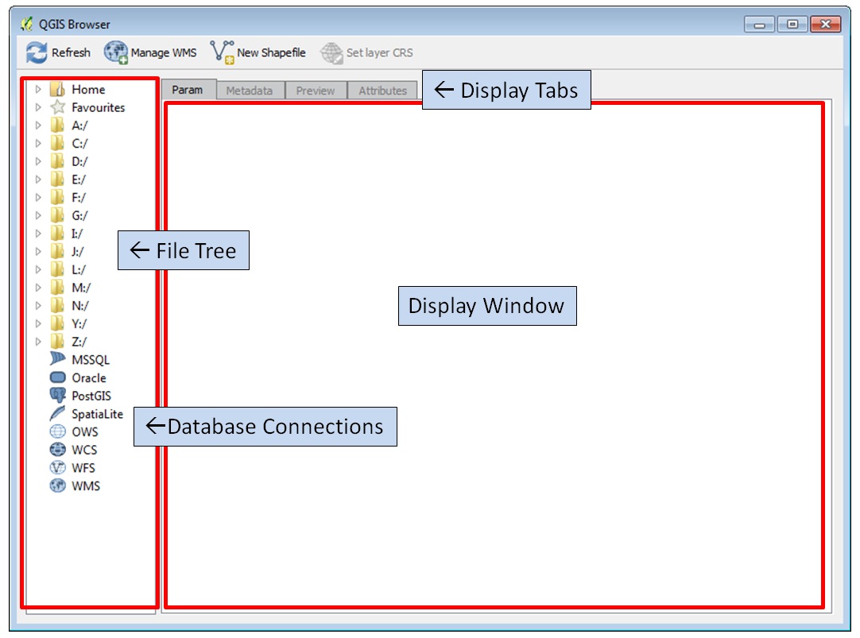

**Figure 2: QGIS Browser**

1. Look at the **File Tree**. **Click** the arrow to the left of the **C:** drive. You will now see all of the subfolders directly under the C:\ folder.
2. **Expand C:\GST101\Lab 2\Data** in the **File Tree** by **clicking the arrows** to the left of each folder. You will now see the contents of the Data folder for the lab (**Figure 3**).

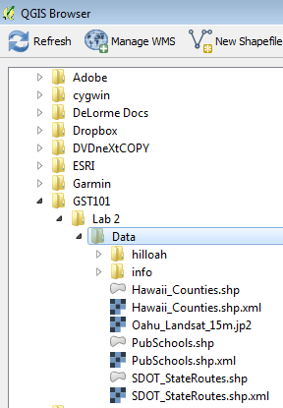

**Figure 3: Lab Data in QGIS Browser**

1. Take a moment to read the names of the files. There are two folders and several files listed with different icons. The  icon indicates that the dataset is a vector layer. The  is used to represent raster data but is also used for other files such as the XML files you see here.
2. Become familiar with geospatial data models

Now that you’re familiar with the basic layout of QGIS Browser we will explore some geospatial data.

1. Let’s take a closer look at these data.
2. **Select** the **Hawaii_Counties.shp** layer in the File Tree. The Display Window automatically switches to the **Metadata** tab. This gives you some basic information about the dataset. You’ll notice that the **Storage type** is **ESRI shapefile**. The **Display Window** also tells you that it has a Geometry type of **polygon** and it has **9** features (**Figure 4**).

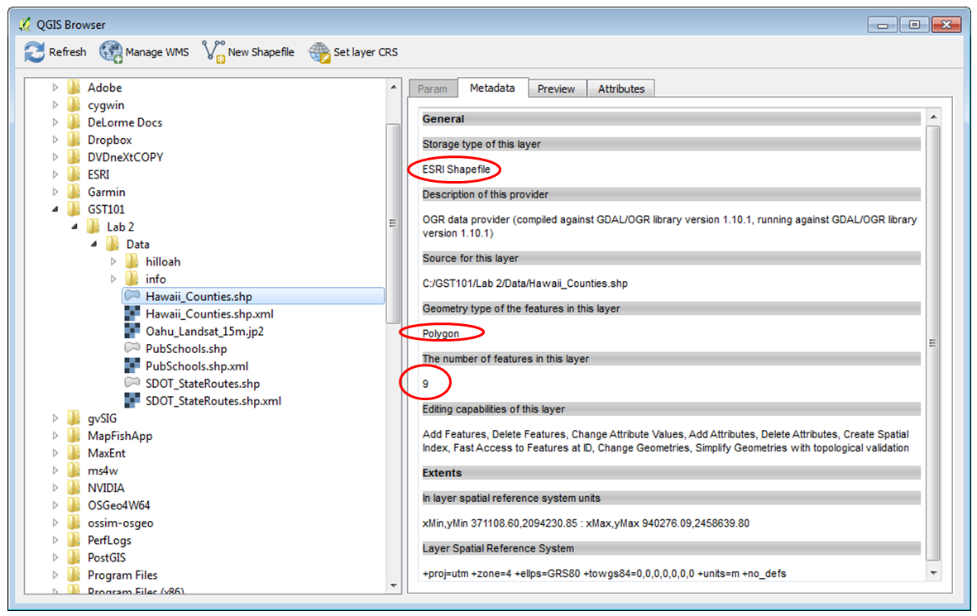

**Figure 4: Metadata in QGIS Browser**

In addition to data models (vector and raster) we have to understand file formats. Some file formats are designed to store vector and others raster data. Shapefiles are vector file format. In fact they are probably the most common vector file format. A particular shapefile can only contain one geometry type (polygon, line or point). A shapefile is actually a collection of files on the computer with a common name, but different extensions.

1. Now **select PubSchools.shp**. You’ll see that this is also an ESRI Shapefile but that it is a point dataset with 287 features.
2. **Select SDOT_StateRoutes.shp**. This is an ESRI Shapefile with line geometry and 122 features.
3. **Select Hawaii_Counties.shp** again and click on the **Preview** tab. This shows you the spatial features of this GIS dataset (**Figure 5**)

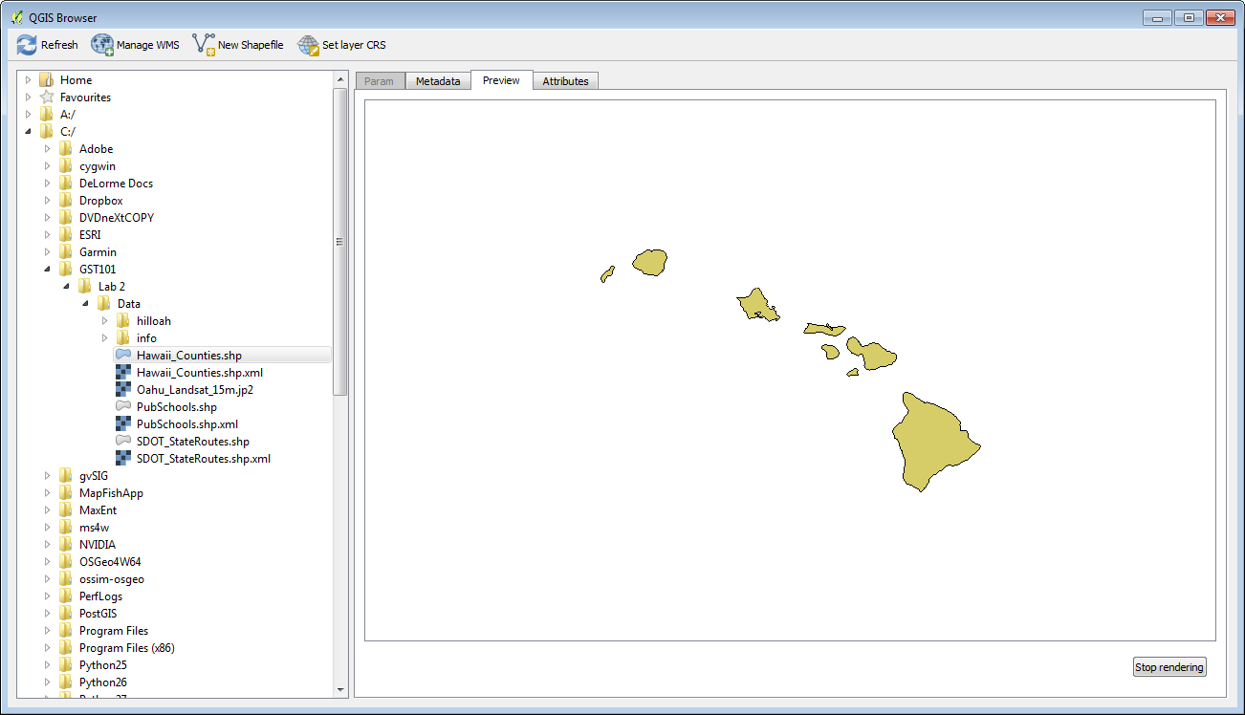

**Figure 5: Preview in QGIS Browser**

1. **Click** on the **Attributes** tab. This shows you the other component of the data model, the attributes. Each row corresponds to one polygon. The columns are things we know about the polygons such as island name (**Figure 6**).

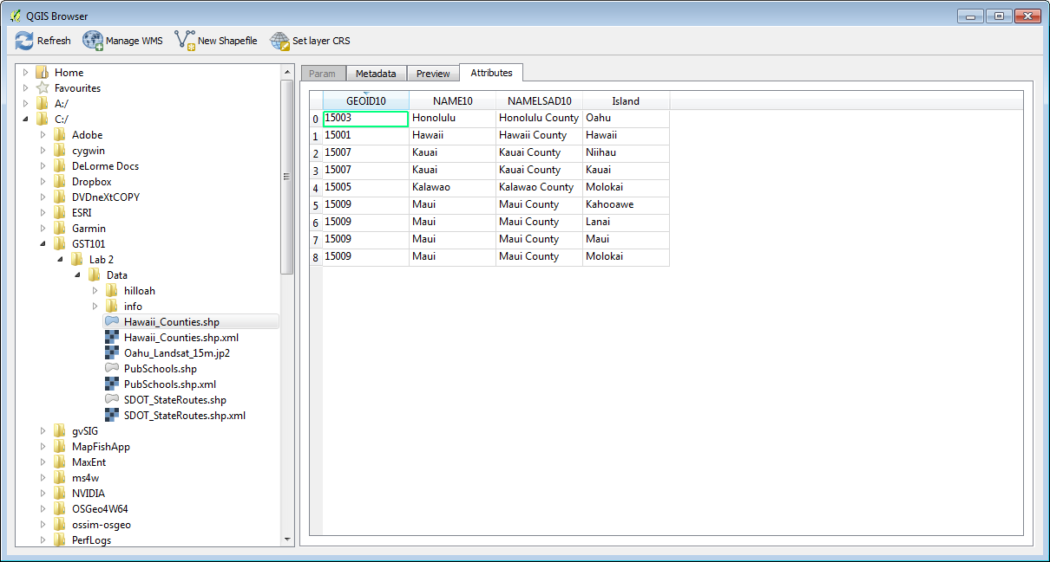

**Figure 6: Attributes in QGIS Browser**

1. **Select** the **Oahu_Landsat_15m.jp2** dataset. Click on the **Preview** tab. This is an example of a raster dataset. Like a photograph, it is composed of cells. This raster is a satellite image of the island of Oahu, Hawaii (**Figure 7**).

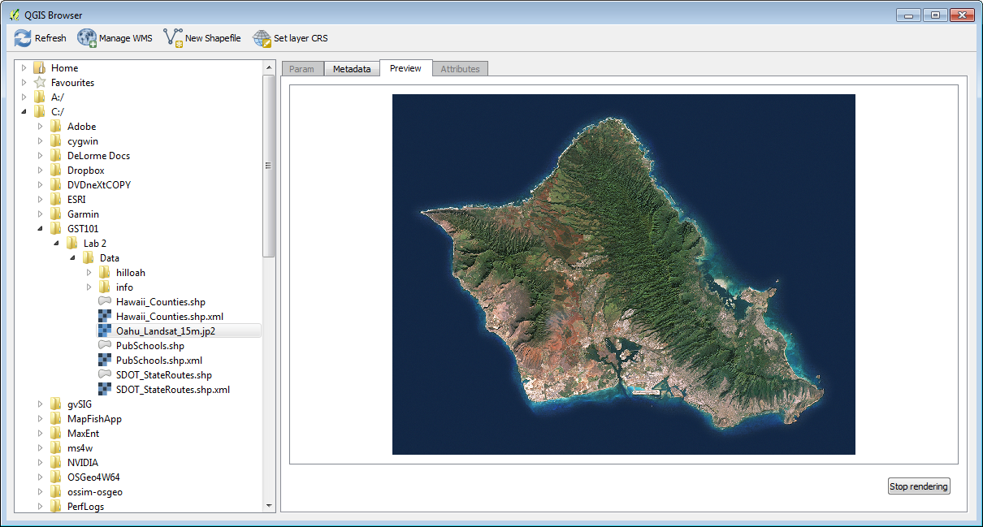

**Figure 7: Raster data Preview**

Let’s look at the file formats in more detail.

1. **Select** the lab **Data** folder in the File Tree. The **Param** tab is all that is available when a folder is selected (**Figure 8**).
2. Now the **Display Window** is showing you what you would see in **Windows Explorer**.

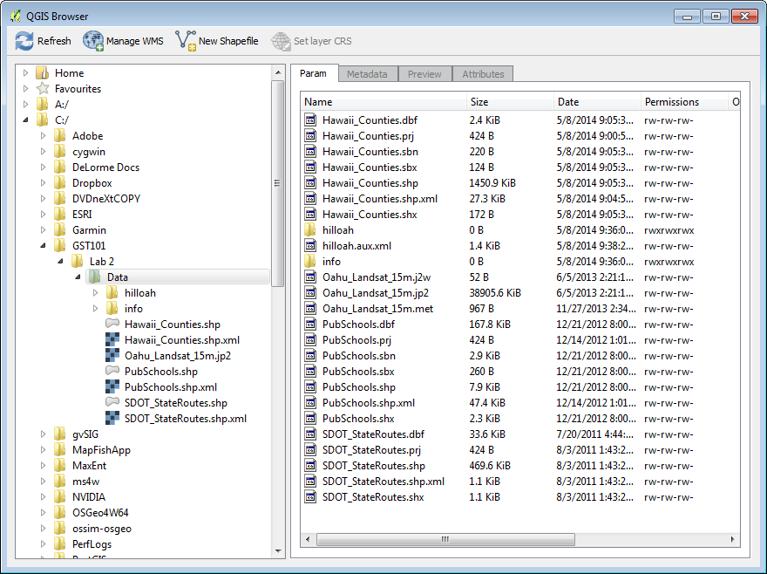

**Figure 8: Folder contents**

Focus on the Hawaii_Counties files. Notice that the File Tree shows that Shapefile just as Hawaii_Counties.shp whereas the Display Window is showing seven files named Hawaii_Counties. These are all the component files of this particular shapefile. The **File Tree** simplifies the view of your data showing you only the *.shp and *.xml files.

For more information on ESRI shapefiles refer to this link <http://en.wikipedia.org/wiki/Shapefile>

1. Viewing geospatial data in QGIS Desktop

Now that you know how geospatial datasets are stored on your computer, let’s see what the data they contain look like. This next section will introduce you to QGIS Desktop.

1. **Click Start 🡪 All Programs 🡪 OSGeo4W 🡪 QGIS Desktop.**
2. QGIS Desktop is the application you will use for setting up and making maps, and doing GIS analyses. It is has two main sections: the **Table of Contents** and the **Map Window**.

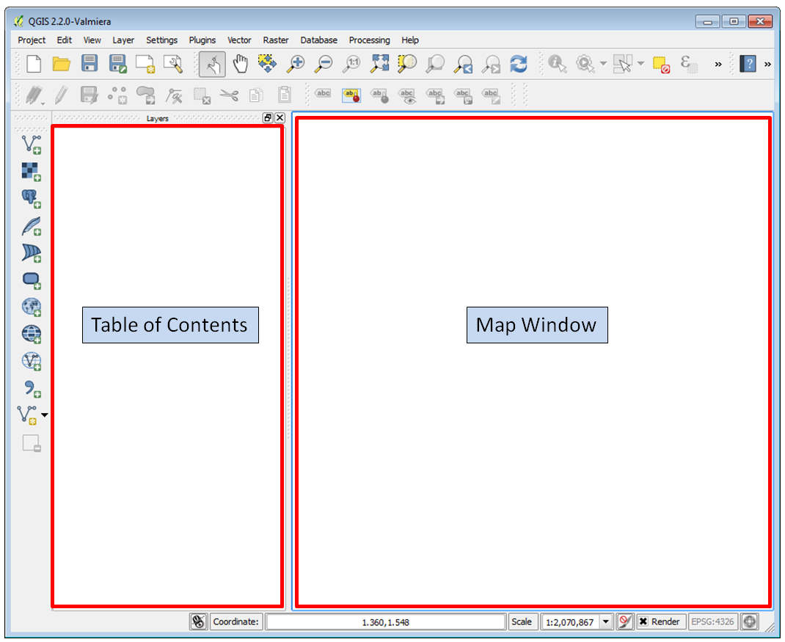

**Figure 9: QGIS Desktop**

Let’s add some data. QGIS has Add Data buttons for each major geospatial data model (vector and raster).

1. **Click** the **Add Vector Layer**  button. It’s located on the toolbar along the left hand side of the Table of Contents.
2. This opens the **Add vector layer** window. Add one of the ESRI shapefiles which is a file based dataset. Keep the **Source type** **"File"** which is the default. Then click the **Browse** button.

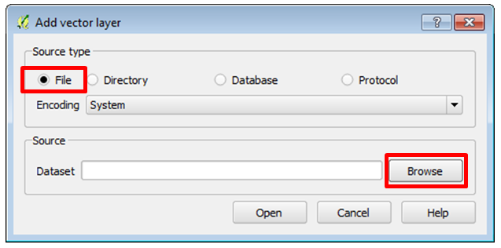

**Figure 10: Add vector layer**

1. The **Open an OGR Supported Vector Layer** window opens. (**NOTE**: OGR is a FOSS4G project that sole purpose is to read and write geospatial vector data files.) The window defaults to ESRI Shapefiles which is perfect. From exploring the lab data in QGIS Browser you know there are several shapefiles. Take a moment to see what other options are there. **Click** the **down arrow** to the right of ESRI Shapefiles [OGR]… (**Figure 11**).

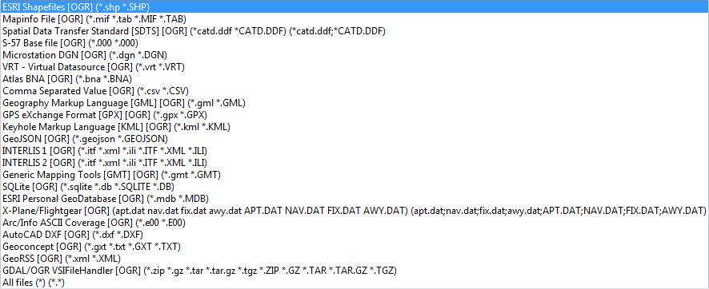

**Figure 11: OGR Supported Vector Formats**

1. Once you’re finished exploring make sure it is still set to ESRI Shapefiles. This filters what you can see in the lab folder so that you only see the shapefiles.
2. **Select** **Hawaii_Counties.shp** and click **Open** (**Figure 12**).

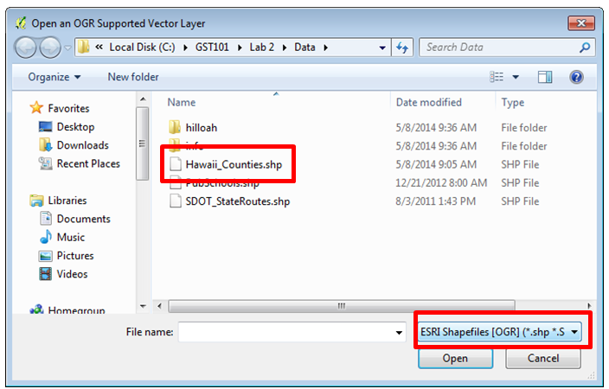

**Figure 12: Open an OGR Supported Vector Layer**

1. Now back at the **Add vector layer** window and click **Open** to add the data to QGIS Desktop (**Figure 13**).

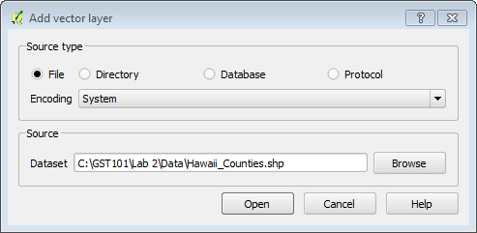

**Figure 13: Add vector layer – Hawaii Counties**

1. You will now see Hawaii_Counties in the Table of Contents and the map features displayed in the map window. Vector GIS layers will come in with random colors. You’ll learn how to change layer styling in a future lab.
2. Let’s examine the attributes. **Right click** on the Hawaii Counties layer in the Table of Contents. This opens a context menu. Select **Open Attribute Table** (**Figure 14**).

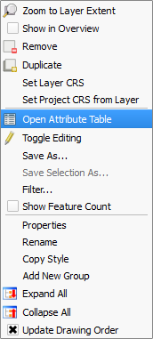

**Figure 14: Layer Context Menu**

1. The table opens. If you recall from exploring this dataset with QGIS Browser, it has 9 features (9 polygons). The attribute table has 9 corresponding records. There are columns with the County name and with the island name. **Close** the Attribute Table by **clicking** **the X** in the upper right hand corner.

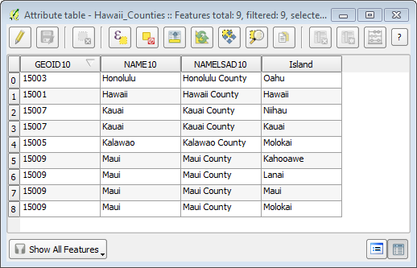

**Figure 15: Attribute Table**

1. Another way to interact with both the spatial features and the attributes is the Identify button .
2. **Click** the **Identify** button 
3. **Click** **on one of the features on the map**. The Identify results window (**Figure 16**) shows you the attributes for the feature you clicked on.

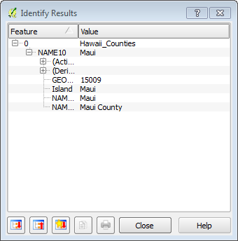

**Figure 16: Identify Results**

Now you will learn how to add Raster data to QGIS Desktop.

1. **Click** the **Add Raster Layer** button 
2. The **Open a GDAL Supported Raster Data Source** window opens (**Figure 17**). This is a very similar workflow to adding vector data.

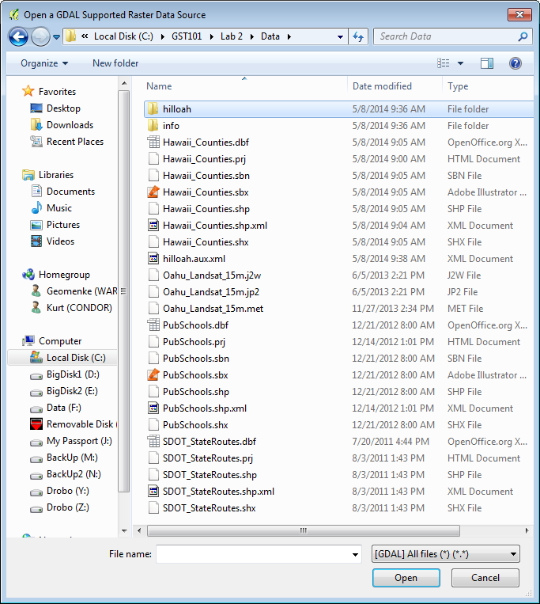

**Figure 17: Open a GDAL Supported Raster Data Source**

1. Whereas QGIS used OGR to open vector data files, here it uses another FOSS4G project called **GDAL**. GDAL is another software library that QGIS uses. It is software for reading and writing raster datasets.
2. The window’s raster data filter is set to **[GDAL] All Files** by default, so you see the entire contents of the folder (**Figure 18**).

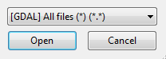

**Figure 18: [GDAL] All Files**

1. Set the filter to **[GDAL] ERDAS JPEG200** (third option from the top). Also, note how many formats it will read! In GIS there are many more raster file types than vector. Once you’ve set the filter you’ll see the one dataset: **Oahu_Landsat_15m.jp2** (**Figure 19**).

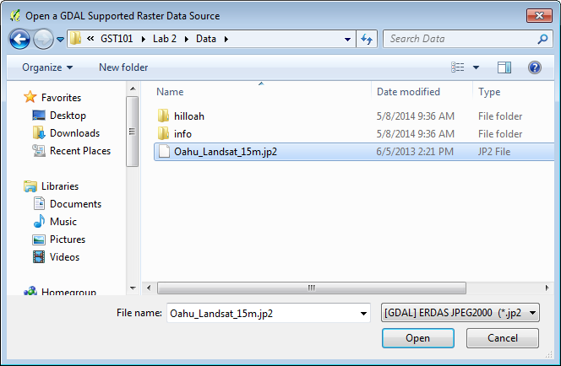

**Figure 19: [GDAL] ERDAS JPEG 2000**

1. **Select** the raster dataset and click **Open**.
2. This dataset only covers a portion of Hawaii, just the island of Oahu. **Right click** on the Oahu Landsat 15m dataset in the Table of Contents and choose **Zoom to Layer Extent** to zoom to the spatial extent of this raster (**Figure 20**).

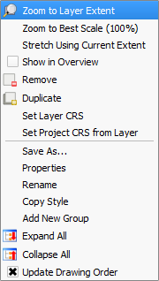

**Figure 20: Zoom to Layer Extent**

You may notice two folders in the lab data folder that we have not discussed yet. One is named **hlloah** and the other **info**. Together these combine to make another geospatial dataset called a GRID. The **info** folder holds the attributes and always has the name "info". The other folder is the layer name and contains the spatial data.

1. Click the **Add Raster Layer** button again.
2. **Set** the filter to **[GDAL] Arc/Info Binary Grid**. It’s about a dozen items from the top of the list. **Double click** the **hilloah** folder to enter it. **Select** the **hdr.adf** file and click **Open** to add the raster to QGIS (**Figure 21**).

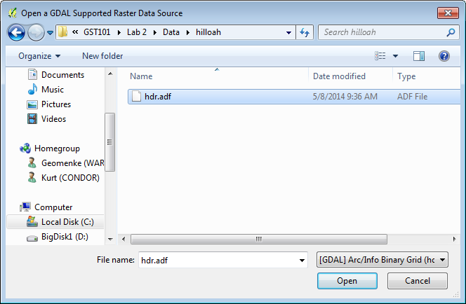

**Figure 21: Adding a GRID to QGIS**

1. This raster is a hillshade image of Oahu and it represents the terrain.

QGIS Desktop also has a browser window.

1. **Right click** on the blank space to the right of the Help menu. This opens a context menu showing all the toolbars and windows that you can add to the QGIS interface. **Check** the box next to **Browser (Figure 22)**. A Browser window is added as a tab to the Table of Contents .

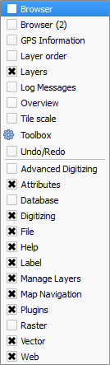

**Figure 22: Toolbars and Windows Context Menu**

1. **Click** on the **Browser Tab**.
2. Note that there is a **Favourites** item. You identify workplaces as being Favourites in order for them to appear here.

Data is often stored deep inside a series of folders. It is often tedious and time consuming to navigate deep inside the folders to gain access to the data. Favourites provide a way to create a shortcut directly to any folder so that you have one-click access to any folder.

1. **Navigate** to the lab data folder. **Right click** on it and choose **Add as a Favourite (Figure 23)**. **NOTE:** Currently this functionality is reserved only for the Browser tab in QGIS Desktop. However, once it is set it will show up as a Favourite in QGIS Browser as well.



**Figure 23: Add as a Favourite**

1. Now **expand** **Favourites** and you’ll see your lab folder listed there. You can remove a Favourite anytime by right clicking on it and choosing **Remove favourite**.
2. **Expand** the lab folder under **Favourites** to expose the contents. Select **SDOT_StateRoutes.shp** and **drag** it onto the **map**. This is a quick way to add data to your map.

**NOTE**: You can drag data from the QGIS Browser application to QGIS Desktop as well.

5 Conclusion

In this lab you have explored datasets that use the two common geospatial data models: vector and raster. You have also used the QGIS Browser to preview datasets. QGIS Desktop also allows users to make maps and perform analyses.

6 Discussion Questions

1. What are the 14 possible file extensions for files that compose a shapefile?
2. How can Browser favourites make your workflow more efficient?
3. What are the two main parts of a GIS data model?
4. Name three ways of seeing feature attributes for a vector GIS layer.